NutriLift: A Fitness and Nutrition Tracking Mobile Application with Community and Gamification Features

Final Year Project Proposal

|  |  |  |  |
| --- | --- | --- | --- |
| **Academic Year** | **Module** | **Task** | **Assessment Type** |
| 2026 | Project and Professionalism | 1 | Individual Report |

Date of Submission: September 07, 2025

Section 1: Student Details

______________________________________________________________________________

Full Name: Luja Ratna Manandhar

Student Number: 2407087

Course: BSc. (Hons) Computer Science

University Email: [L.R.Manandhar@wlv.ac.uk](mailto:L.R.Manandhar@wlv.ac.uk)

Supervisor: Johan Tandukar

Reader: Yogesh Bikram Shah

Table of Contents

Section 2: Statement of Project Details 1

Project Title: 1

Aims: 1

Objectives: 1

Artefact (Proposed): 2

Section 3: Project Proposal 3

Introduction: 3

Background and Problem Scenario: 3

The Project as a Solution: 4

Initial Research into Sources of Information: 4

Artefact (Proposed): 6

Justification of Artefact: 7

Methodology: 8

Database 8

Testing Plan: 9

Plan and Schedule: 10

Functional Decomposition & Subsystems 11

References 13

Project Risks, Threats, and Contingency: 14

Resources: 14

Client: 14

Table of Figures:

Figure 1: Gantt Chart 9

Figure 2: FDD Diagram 10

## Section 2: Statement of Project Details

____________________________________________________________________________

## Project Title:

**NutriLift:** A Fitness and Nutrition Tracking Mobile Application with Community and Gamification Features.

Academic Question:

1. How effective is the integration of fitness, nutrition, gamification, and community in improving user motivation and consistency compared to single-purpose health apps?

2. To what extent do gamification features (such as badges, streaks, and challenges) improve long-term engagement in health and fitness applications?

3. Can a community-driven fitness app designed for affordability and simplicity reduce the abandonment rates observed in existing premium fitness and nutrition apps?

### Aims:

The aim of this project is to design and develop a simple, affordable, and engaging mobile application that combines fitness, nutrition tracking, gamification, and community features to help users maintain a consistent and healthier lifestyle.

### Objectives:

- Review current fitness and nutrition apps and point out their limitations.

• Add an AI-powered Rep Count feature using Google ML Kit Pose Detection in Flutter to automatically count exercise repetitions via camera tracking.

- Design the layout and user interface for NutriLift using a user-centred design approach.

- Develop the core functions such as profiles, nutrition logs, workout logs, and challenges.

- Build a community section where users can post, comment and join challenges together.

- Add progress tracking and visual reports to show improvements over time.

- Test the app with students to check usability and gather feedback.

- Write the full documentation, reflect on the findings, and suggest improvements for the future.

### Artefact (Proposed):

The artefact will be a mobile application that works on Android and iOS. It will allow users to log their meals, track workouts, join health challenges, and connect with a small online community. The main focus will be on making the app simple, friendly, and helpful for beginners, especially students who cannot afford expensive paid apps.

## Section 3: Project Proposal

______________________________________________________________________________

### Introduction:

In today’s world, more people are becoming aware of the need to stay healthy, but many struggle with keeping up a balanced lifestyle. Mobile apps have become a common way to track food, workouts, and daily activity. However, most of the popular apps either focus on only one area, such as calories or workouts, or they make important features premium and difficult to access. This proposal presents NutriLift, a fitness and nutrition app that aims to combine healthy living tools with challenges and a community to keep people motivated.

### Background and Problem Scenario:

Existing apps like MyFitnessPal, Strava, and Fitbit are widely used, but each one has gaps. MyFitnessPal is mainly for food tracking but does not focus much on fitness. Strava and Nike Training are strong in workouts but do not track meals properly. Fitbit combines more features, but it works best with their devices and is not always affordable for students. In addition, many apps hide their best functions behind paid subscriptions. Beginners often feel lost because the apps are too complex, while advanced users may lose interest because there is no fun or challenge system.

According to the (Organization, 2024) approximately **31% of adults worldwide** did not meet the recommended levels of physical activity in 2022, which significantly increases the risk of obesity and non-communicable diseases. Similarly, the *Health & Fitness App Report 2024* by (Apps, 2024)highlights that user retention in fitness apps declines sharply, dropping from **37% on day 1** to **9% by day 28**, and as low as **3% by day 30** (Apps, 2025). This indicates a critical challenge in sustaining long-term user engagement.

In the Nepalese context, a study conducted in Kathmandu revealed that **61.1% of urban youth had low physical activity levels**, **75.4% consumed inadequate fruits and vegetables**, and **41.3% were overweight or obese** (Anil, 2019). These findings underscore a major urban health concern, emphasizing the urgent need for an engaging, sustainable lifestyle-tracking solution that keeps users motivated while promoting healthier habits.

### The Project as a Solution:

NutriLift will directly address these problems. It will combine nutrition and fitness tracking in one place so users do not need multiple apps. Challenges and gamification will add fun and help users stay consistent. A community feed will allow people to share their progress, motivate each other, and join group challenges. The app will be designed to be clean and simple, following HCI principles so that even first-time users can use it without confusion. Core features will be free, making it attractive for students who cannot afford paid apps.

### Initial Research into Sources of Information:

Recent developments in artificial intelligence have significantly influenced the design of modern fitness and exercise applications. For example, (Chae, 2023) developed an AI-powered exercise coaching app capable of analysing posture and counting repetitions in real time. This shows how mobile applications can support users in maintaining proper form and tracking their workouts more efficiently. Similarly, (Jaiswal, 2023) explored the use of learnable physics for providing real-time feedback on exercise form, which highlights the practical benefits of accurate pose estimation during training sessions. In addition, (Shin, 2025) introduced a conversational system driven by large language models to generate personalised workout plans, demonstrating how artificial intelligence can tailor routines according to each user’s fitness goals and preferences. Together, these studies provide strong evidence that integrating AI-based pose detection and personalised feedback, such as through Google ML Kit, can greatly enhance user motivation, technique, and overall training outcomes.

One of the clearest issues is **usability**. Many mobile health applications are difficult for beginners to navigate. (Moura, 2021) found that most mHealth apps have cluttered layouts and confusing designs, which often lead to frustration and early abandonment. This is an important lesson for NutriLift, which will be built with Human-Computer Interaction (HCI) principles in mind to make the interface clear, simple, and beginner-friendly.

A second theme in the research is **motivation**. (Sardi, 2017) showed in their review that gamification techniques—such as badges, streaks, and leaderboards—can make digital health platforms much more engaging. Without these features, users tend to lose interest quickly. This evidence strongly supports the decision to add challenges and rewards to NutriLift so that users stay motivated over time.

The importance of **community support** is also well recognised. According to (Maher, 2014), people who take part in online health communities are more likely to stay active because they receive encouragement and accountability from peers. NutriLift’s planned community feed directly responds to this evidence by allowing users to share progress and join group challenges, creating a supportive environment.

Looking ahead, there is growing interest in the role of **artificial intelligence** in health apps. (Topol, 2019) argues that AI can personalise health advice, predict user needs, and make digital tools more meaningful to individuals. This insight supports the optional AI features being considered for NutriLift, such as personalised meal suggestions and food recognition through images.

However, even with these tools, many apps fail to keep users engaged for long. (Dennison, 2013) found that health apps often lack theoretical grounding and are unable to support lasting behaviour change. Industry data reinforces this point: the Business of Apps benchmark report shows that only about **3.7% of users remain active after 30 days** of downloading a health or fitness app (Apps, 2025). This highlights the real problem NutriLift aims to solve helping users stay engaged consistently.

In summary, existing research shows that poor usability, weak motivational features, and limited long-term support are the main weaknesses of current health apps. Evidence also suggests that gamification, community support, and AI-based personalization can make apps more effective. By combining these elements, NutriLift aims to offer a more practical, motivating, and user-friendly solution.

To better understand NutriLift’s unique value, the table below compares it with existing applications:

|  |  |  |  |  |
| --- | --- | --- | --- | --- |
| Feature | MyFitnessPal | Strava | Fitbit | NutriLift |
| Nutrition Tracking | Yes | No | Limited | Yes |
| Workout Tracking | No | Yes | Yes | Yes |
| Gamification | No | Limited | Limited | Yes |
| Community Support | No | Yes | Limited | Yes |
| Free Access to Core Features (basic nutrition + fitness tracking without paywall) | No | Yes | No | Yes |

### Artefact (Proposed):

The final artefact will be a mobile application developed using Flutter, with PostgreSQL as the backend for authentication, database, and storage. The app will run on both Android and iOS. Its design will follow proper design principles, ensuring it is simple, intuitive, and beginner-friendly.

The artefact will include the following features:

**Core Features**

* **User Management** → Registration, login, profile settings, and password recovery.
* **Nutrition Tracking** → Meal logging, calorie and macro breakdown, searchable food database, and hydration tracker.
* **Workout Tracking** → Exercise logging, custom workout builder, and workout history storage.
* **Community Module** → Users can post updates, comment, and join group challenges for motivation.
* **Challenges & Gamification** → Daily and weekly goals, streaks, badges, and leaderboards to increase engagement.
* **Progress Reports** → Visual charts, graphs, and summaries displaying nutrition and workout progress over time.
* **Payment Integration** → Premium features can be unlocked through a payment gateway.
* **Admin Panel** → For managing users, moderating content, and monitoring community activity.

**Unique & Advanced Features**

* **Rep Count Feature** → Uses Google ML Kit Pose Detection in Flutter to track body movement and automatically count exercise repetitions in real time, improving accuracy and motivation.
* **Streak Rewards** → Encourages long-term consistency by rewarding users with badges and points for maintaining activity streaks.
* **Quick Log** → One-tap entry for frequently used meals and workouts, saving time during daily logging.
* **Mood & Energy Tracker (Optional)** → Allows users to log daily mood and energy levels, helping them understand correlations with diet and exercise.
* **Optional AI Features** → Includes personalised diet and workout recommendations, as well as an **AI chatbot** for answering questions, giving motivational prompts, and guiding users (future upgrade).

The aim is to deliver a working mobile application that is simple, engaging, and tested with real users. If time allows, advanced features such as AI will be implemented to extend the artefact further.

### Justification of Artefact:

The artefact is important because it addresses the gap between existing apps and what users actually need. While many apps exist, very few combine fitness, nutrition, challenges, and community in one place. This project relates directly to the academic question because it explores how combining these features with good usability can help users stay consistent. The artefact is not only technical but also focused on solving a real-world problem, making it meaningful both academically and practically.

### Methodology:

The project will follow the Scrum methodology, which is a framework under the Agile mindset. Scrum is suitable for this project because it allows development in iterative sprints, encourages continuous feedback, and adapts easily to changes.  
  
Roles:  
- Product Owner: Supervisor  
- Scrum Master: Student Developer  
- Development Team: Student Developer

Process:  
- Development will be split into 1 week sprints.  
- At the end of each sprint, a review meeting will take place with the supervisor.  
- Deliverables will be presented incrementally (UI mockups, core features, community module, etc.).

Database:

NutriLift will use PostgreSQL, a relational and open-source database that is reliable and widely adopted in academia and industry.  
  
Backend Framework: Django REST Framework (Python) or Node.js with Express  
Database: PostgreSQL  
Advantages: Strong relational support, scalability, ACID compliance, and open-source availability.

### Testing Plan:

Testing will be done at several levels. Unit testing will check if individual parts, like logging a meal or updating a profile, work correctly. Integration testing will make sure that nutrition, fitness, and community modules work smoothly together. Usability testing will be carried out with 15–20 student users who will complete tasks and give feedback. Performance testing will ensure that the app responds quickly. Finally, acceptance testing will confirm that the app meets the project aims and objectives.

The Rep Count feature will be tested for accuracy by comparing detected counts with manual observations, evaluating performance under varying light and camera conditions.

### Plan and Schedule:

The project schedule will follow the official FYP Calendar.

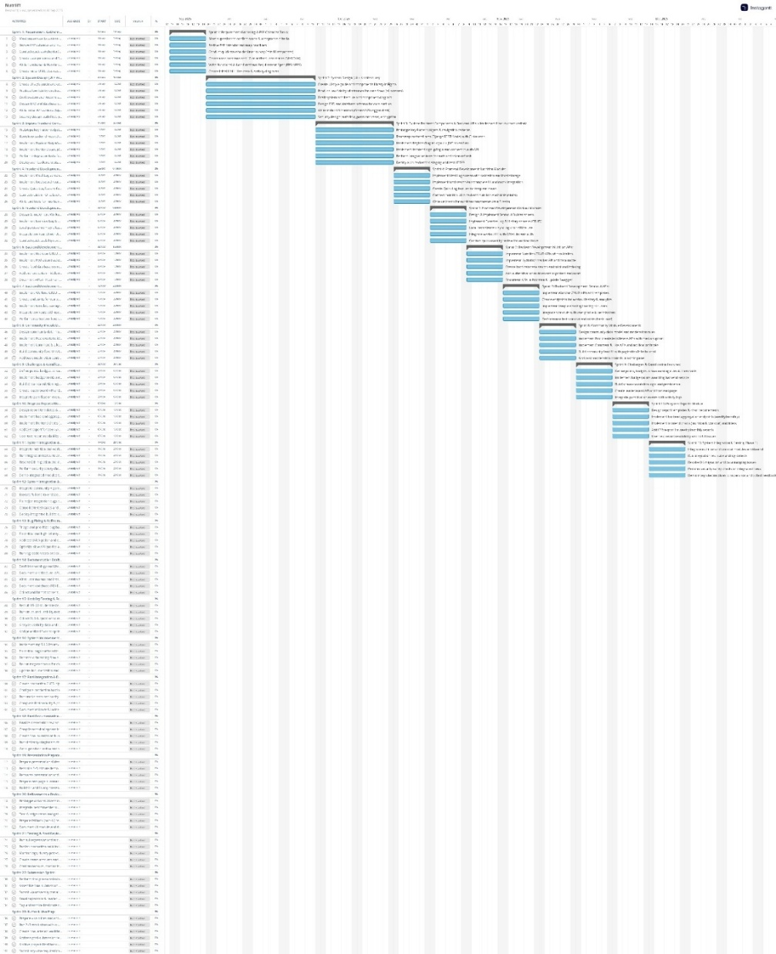

Figure : Gantt Chart

### Functional Decomposition & Subsystems

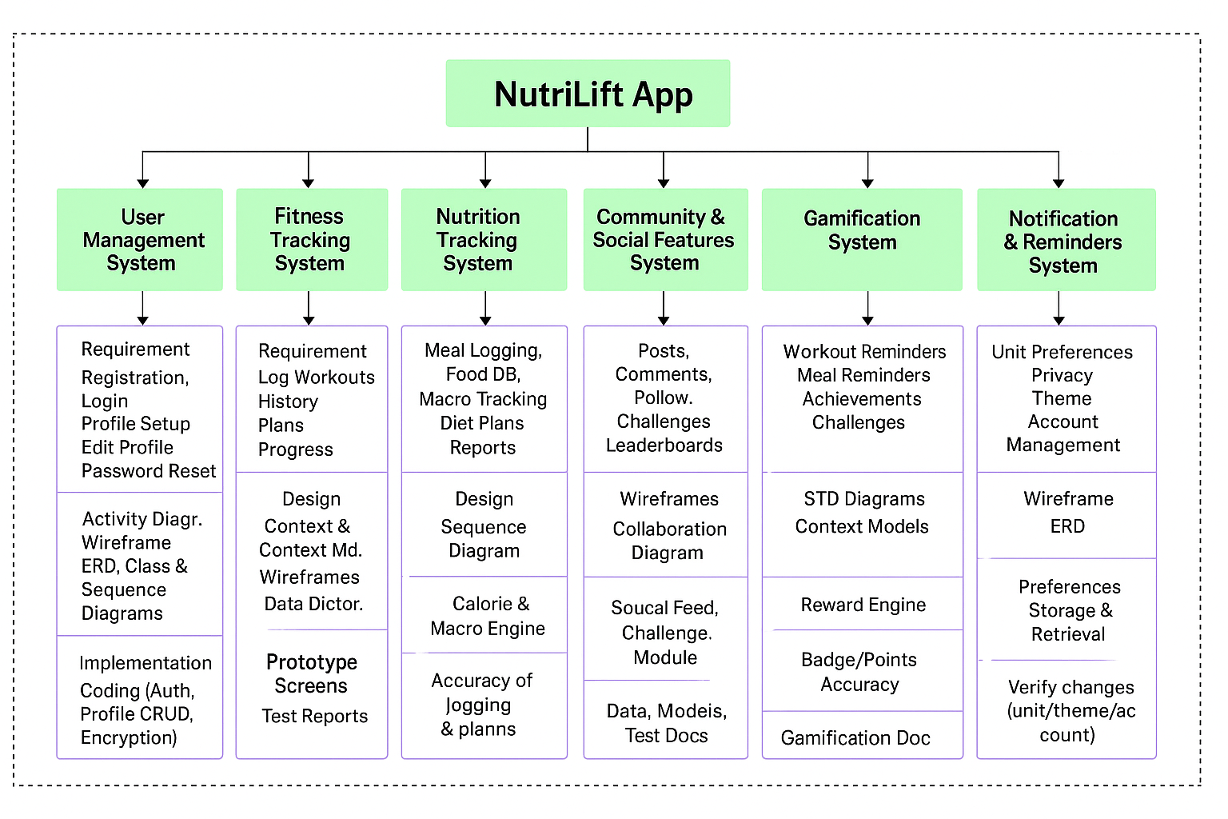

Figure : FDD Diagram

**Functional Decomposition**

* User Management (Registration, Login, Profile).
* Nutrition Tracking (Meal logs, Hydration tracker, Quick Log).
* Workout Tracking (Exercise logs, Custom workout builder).
* Challenges & Gamification (Goals, Streak Rewards, Badges, Leaderboards).
* Rep Count Module (Camera-based Pose Tracking) → Integrates Google ML Kit Pose Detection to detect user posture and count repetitions automatically through real-time camera tracking.
* Community Module (Posts, Comments, Group Challenges).
* Progress Reports (Charts, Summaries, Weekly Wellness Score).
* Payment Integration (Premium access via international + Nepali gateway).
* Admin Panel (User monitoring, Content moderation).
* Optional AI Features (AI Chatbot, Personalised Recommendations)

**Subsystem Explanation**

* **User Management:** Handles user registration, login, and personal profile management.
* **Nutrition Tracking:** Allows users to log meals with calorie and nutrient breakdown, track hydration, and use Quick Log for frequently eaten meals.
* **Workout Tracking:** Enables recording of exercises, saving custom workouts, and storing workout history.
* **Challenges & Gamification:** Offers daily/weekly goals, provides streak rewards, badges, and ranks users in leaderboards.
* **Community Module:** A social space for users to share posts, comment, and participate in group challenges.
* **Progress Reports:** Displays weekly and monthly progress through visual charts and summaries; generates a wellness score.
* **Payment Integration:** Unlocks premium features through a secure payment gateway supporting both international and Nepali options.
* **Admin Panel:** Allows administrators to manage accounts, moderate posts, and handle reports.
* **Optional AI Features:** Includes an AI chatbot for guidance and motivational messages, with potential upgrades for personalised diet/workout recommendations.

## References

Anil, O. S. A. a. S. R., 2019. Prevalence of Cardiovascular Risk Factors in Apparently Healthy Urban Adult Population of Kathmandu. *Journal of Nepal Health Research Council,* 17(2), pp. 181-186.

Apps, B. o., 2024. *Health & Fitness App Report 2024,* s.l.: Business of Apps.

Apps, B. o., 2025. *Health & Fitness App Benchmarks (2025).* [Online]   
Available at: https://www.businessofapps.com/data/health-fitness-app-benchmarks/  
[Accessed 2 September 2025].

Chae, H. K. Y. P. S. a. L. J., 2023. An Artificial Intelligence Exercise Coaching Mobile App. *Interactive Journal of Medical Research,* Volume 12(1).

Dennison, L. M. L. C. G. a. Y. L., 2013. Opportunities and challenges for smartphone applications in supporting health behaviour change: qualitative study. *Journal of Medical Internet Research,* 15(4), p. e86.

Guthold, R. e. a. (. W. r. g., 2024. Global levels of physical inactivity in adults: off track for 2030. *The Lancet Global Health.*

Jaiswal, A. C. G. a. S. N., 2023. Using Learnable Physics for Real-Time Exercise Form Recommendations. *Proceedings of the 17th ACM Conference on Recommender Systems (RecSys ’23),* p. 701–705.

Maher, C. R. J. A. C. a. E. S., 2014. Users’ experiences of social media for physical activity: a systematic review of qualitative studies. *American Journal of Preventive Medicine,* 47(6), p. 647–655.

Moura, L. a. C. J., 2021. Usability issues in mobile health applications: a systematic review. *Journal of Mobile Technology in Medicine,* 10(1), p. 15–28.

Organization, W. H., 2024. Nearly 1.8 billion adults at risk of disease from not doing enough physical activity.

Sardi, L. I. A. a. F.-A. J., 2017. A systematic review of gamification in e-Health. *JMIR Serious Games (Journal of Medical Internet Research: Serious Games),* 5(2), p. e18.

Shin, D. H. G. a. K. Y.-H., 2025. PlanFitting: Personalized Exercise Planning with Large Language Model-Driven Conversational Agent. *Proceedings of the 7th ACM Conference on Conversational User Interfaces (CUI ’25).*

Topol, E., 2019. *Deep Medicine: How Artificial Intelligence Can Make Healthcare Human Again.* New York: Basic Books.

Section 4: Additional Information

### Project Risks, Threats, and Contingency:

- Time limitations: Focus on finishing the core app first and leave optional features for later.  
- Usability risks: Carry out early tests and make changes based on student feedback.  
- Technical issues with PostgreSQL: Prepare a backup plan using another backend like Django if needed.  
- Privacy risks: Use safe login, store minimal personal data, and follow GDPR rules.

### Resources:

- Frontend: Flutter (cross-platform mobile development)  
- Backend: Django REST Framework   
- Database: PostgreSQL  
- Deployment Platform: AWS  
- Payment Platform (if required)  
- Version Control: Git & GitHub  
- Design Tools: Figma (for prototyping)

The project will need a laptop and a smartphone for testing. Access to university digital library and online sources will be needed for research. No special hardware is required, which makes the project achievable with limited resources.

### Client:

The academic supervisor, Mr. Johan Tandukar, will act as the client, giving regular feedback on the app’s development. The reader, Mr. Yogesh Bikram Shah, will also be involved in the evaluation process. The target users are mainly students, who will also be engaged in testing the app.